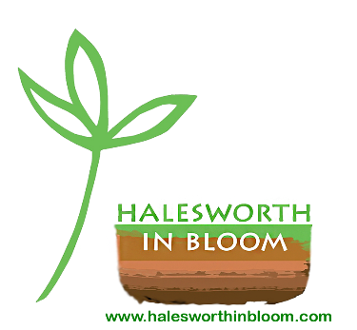
HALESWORTH IN BLOOM AGM
16th April 2024
FINANCE REPORT as at 15th April 2024

As at 15 April 2024, Halesworth in Bloom’s account balances totalled £16,116.21. However, this includes some ring-fenced sums:
- £1,010.00 remaining of Tamsyn Imison’s posthumous donation towards labour costs
- £2,481.51 still to be spent from a Suffolk Community Foundation award for the Town Park
- £204.14 left from money given to maintain the planting of the Malt Trail wherry bed in the Town Park
- £57.55 in hand from Tamsyn memorials donations
Our actual available balance is £12,363.01.

Since the 2022 AGM our income has totalled £6,293 and our expenses came to £4,825.

INCOME: 13 May 2024 – 15 April 2024
- Grant funding: Halesworth Town Council granted us a total of £5,000 (£2,000 for 2022/3 and £3,000 for 2023/24).
- Funding by businesses: we’ve received £500 towards the maintenance of the town’s roundabouts, sponsored by Angel Podiatry, Huus and Attik (replacing Hammonds); plus £100 donated by Waveney Windows and £100 donated by Red Dune Web & IT.
- Open Gardens in 2023: after expenses, donations totalled £305.
- Sale of books left by Tamsyn Imison: £168.
- Cash donations by individuals: Friends of Halesworth in Bloom have donated £75.
- We’re still finding buyers for the Hooker Bicentenary tea towels: a further £45 (total sales since 2017: £1,500).

MAIN EXPENSES: 13 May 2022 – 15 April 2024
- Plants, trees, compost & other associated costs: £1,035 (Thoroughfare planters, Memorial Garden, Town Park, roundabouts, plus a Catalpa tree to commemorate the Platinum Jubilee and a King Charles III rose to commemorate the Coronation)
- New planters in the Thoroughfare: £240
- Labour: £1,320
- Website – hosting costs (3 years), maintenance, email service: £1,162
- Costs of HIB awards ceremony in 2022 (no awards in 2023): £277
- Public liability insurance (3 years): £230
- Celebratory lunch for HIB volunteers 2023: £163
- Cost of soil improver for Edgar Sewter school gardening club beds: £123
- Publicity: £142 (printing of posters & fliers; display at Climate Change conference)
- Affiliation to the RHS (2 years): £90

Liz Wooster, HIB Finance Officer
15 April 2024

